UNIT ONE
Introduction
Data, information, information System
Data: is a collection of raw facts.
Information: is a processed data in the form that is meaningful to the user.
Information System is a system that:
• Receives data and instruction
• Processes the data as per the instruction
• Produces output
• Stores data/information for future use
Information System and Organization, database system
Information System doesn’t exist without organization. That is, organization of data is necessary if data is voluminous. Information System is a support system for the organizational activity to achieve a certain goal.

A database system is basically a computerized record keeping system. Users of the database can perform a variety of operations. Such as:
- Adding new data to empty file
- Adding new data to existing file
- Retrieving data from existing file
- Modifying data to existing file
- Deleting data from existing file
- Searching for target information
Data handling approaches
Data management passes through the different levels of development along with the development in technology and services. These levels could be best described by categorizing the levels into three levels or types of development/approach. Even though there is an advantage and a problem overcome at each new data handling approach/level, all methods or approaches of data handling are in use to some extent. The major three approaches/levels are discussed as follows:

- Manual Approach
In the manual data handling approach, data storage and retrieval follows the primitive and traditional way of data/information handling where cards and paper are used for the purpose. Typing the data on paper and put in a file cabinet. The data storage and retrieval will be performed using human labour. This approach Works well if the number of items to be stored is small.
Limitations of the Manual approach
    - Prone to error
    - Data loss: due to damaged papers or unable to locate it.
    - Redundancy: multiple copies of the same data within the organization.
    - Inconsistency: Modifications are not reflected on all multiple copies
    - Difficult to update, retrieve, integrate
    - You have the data but it is difficult to compile the information
    - Limited to small size information
    - Cross referencing is difficult

An alternative approach of data handling is a computerized way of dealing with the information. The computerized approach could also be either decentralized or centralized base on where the data resides in the system.
- File based Approach
After the introduction of computer for data processing to the business community, the need to use the device for data storage and processing increase. File based data handling approaches were an early attempt to computerize the manual filing system. There were, and still are, several computer applications with file based processing used for the purpose of data handling. It is a collection of application programs that performs services for the end users. In such systems, every application program that provides service to end users define and manage its own data. Such systems have number of programs for each of the different applications in the organization. And this approach is the decentralized computerized data handling method.

Limitations of the File Based approach
As business application become more complex and demanding more flexible and reliable data handling methods, the shortcomings of the file based system became evident. These shortcomings include, but not limited to:
- Separation/Isolation of data
When data is isolated in separate files, it is difficult to access data that should be available. This is because; there is no concept of relationship between files. Therefore, we need to create a temporary file for the participating files.
- Duplication of data (Redundancy)
This is concerning with storage of similar information in multiple files.
The following are some of the disadvantage of redundancy:
- It costs time and money to enter the data
- It takes up additional storage space (memory space)
- Inconsistency: this is loss of data integrity. For instance, if modification in the child table is unable to be reflected on the parent table.
- Data Dependence
Changes to an existing structure are difficult to make. Example: change in the size of Student Name (from 20 characters to 30 characters) requires a new program to convert student file to a new format. The new program opens original student file, open a temporary file, read records from original student file and write to the temporary file, delete the original student file and finally rename the temporary file as student file. It is time consuming and Prone to error.
- Incompatible file formats
The structure of file is dependent on the application programs. Incompatibility of files makes them difficult to process jointly. Example: consider two files with in the same enterprise but in different departments, or in different branches: If the first file is constructed using COBOL and the second file is written using C++, then there will be a problem of integrity.

- Database Approach
What is a Database?
A database is a collection of related data in an organized way. Most of the time, organization is in tabular form. E.g. book database
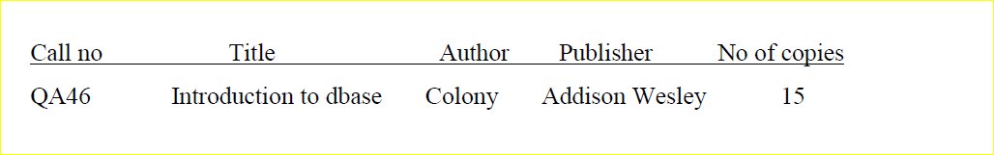
The organization of the database becomes necessary when the data is voluminous. Otherwise, managing data will be very difficult.
E.g. A Manufacturing Company with product data
A Bank with account data
A Hospital with patients
A University with Students
A government with planning data

What is a database system?
It is a computerized record keeping system, which stores related data in an organized way. The overall purpose of a database system is to store information and to allow users to add, delete, retrieve, search, query and update that information upon request. The information concerned can be anything that is deemed to be of significance to the individual or organization the system is intended to serve. That is, needed to assist in the general process of running the business of that individual or organization.
Thus in database approach:
- Database is just a computerized record keeping system or a kind of electronic filing cabinet.
- Database is a repository for collection of computerized data files.
- Database is a shared collection of logically related data designed to meet the information needs of an organization. Since it is a shared corporate resource, the database is integrated with minimum amount of or no duplication.
- Database is a collection of logically related data where these logically related data comprises: entities, attributes, relationships, and business rules of an organization's information.
- In addition to containing data required by an organization, database also contains a description of the data which called as “Metadata” or “Data Dictionary” or “Systems Catalogue” or “Data about Data”.
- Since a database contains information about the data (metadata), it is called a self descriptive collection on integrated records.
- The purpose of a database is to store information and to allow users to retrieve and update that information on demand.
- Database is designed once and used simultaneously by many users.
- Unlike the traditional file based approach in database approach there is program data independence. That is the separation of the data definition from the application. Thus the application is not affected by changes made in the data structure and file organization.
- Each database application will perform the combination of: Creating database, Reading, Updating and Deleting data.
The advantages of a database approach over the traditional and paper-based methods of record keeping will include the following:
Compactness: no need for possibly voluminous paper files.
Speed: the machine can retrieve and change data faster than a human can. In particular, ad hoc, spur-of-the-moment queries
(“Do we have more red screws than blue ones?”) can be answered quickly without any need for time consuming manual or visual searches.
Accuracy: timely, accurate and up-to-date information is available on demand at any time.

The foregoing benefits apply with even more force in a multi-user environment where the database is likely to be much larger and much more complex than in the single user case. In a multi-user environment the database system provides the enterprise with centralized control of its data. The centralized approach has the following advantages:
Data can be shared: two or more users can access and use same data instead of storing data in redundant manner for each user.
Redundancy can be reduced: In non database or non centralized systems each application or department keeps its own private files. The files may hold common data elements that exist as part of the enterprises data. This will lead to considerable redundancy in stored data, with resultant waste in storage space. For example, a personnel application and an education records application might both own a file that includes department information for employees. Note that, this is not to say we should eliminate all redundancies. Sometimes there are sound reasons for maintaining several copies of the same data.
Inconsistency can (to some extent) avoided: If there are a number of files which store similar data elements among other sorts of data then when a change is made to a particular data (among the common ones) this change need to be done throughout the system where there is such data stored. This is not, often, the case. Some of the data might be updated and others left as they are which results in inconsistent information about the same phenomena.
Standards can be enforced: Standardizing data representation is particularly desirable as an aid to data interchange or migration of data between systems. Likewise, data naming and documentation standards are also very desirable as they facilitate data sharing and understandability.
Security restrictions can be applied: Since the data is stored in one place/area all accesses to the data can be regulated by the system through some defined rules built into the system. The system ensures that the only means of access to the database is through proper channels. Different rules can be established for each type of access (retrieve, insert, delete, etc.) to each of information to the database.
Integrity can be maintained The problem of integrity is the problem of ensuring the data in the database is accurate. Inconsistency between two entries that represent the same “fact” is an example of lack of integrity. It is more serious in a multi-user environment where one user may enter bad data and other users may go on working on the updated data as if it were a correct one.
Conflicting requirements can be balanced: knowing the overall requirements of the enterprise the Database Administrator (DBA) can structure the system so as to provide an overall service that is best for the enterprise. For example, a representation can be chosen for the data in storage that gives fast access for the most important applications (possibly at the cost of poorer performance for certain other applications).
Transaction support can be provided: basic demands of any transaction support systems are implanted in a full scale DBMS.
Improved decision support: the database will provide information useful for decision making.
Less labour: unlike the other data handling methods, data maintenance will not demand much resource.
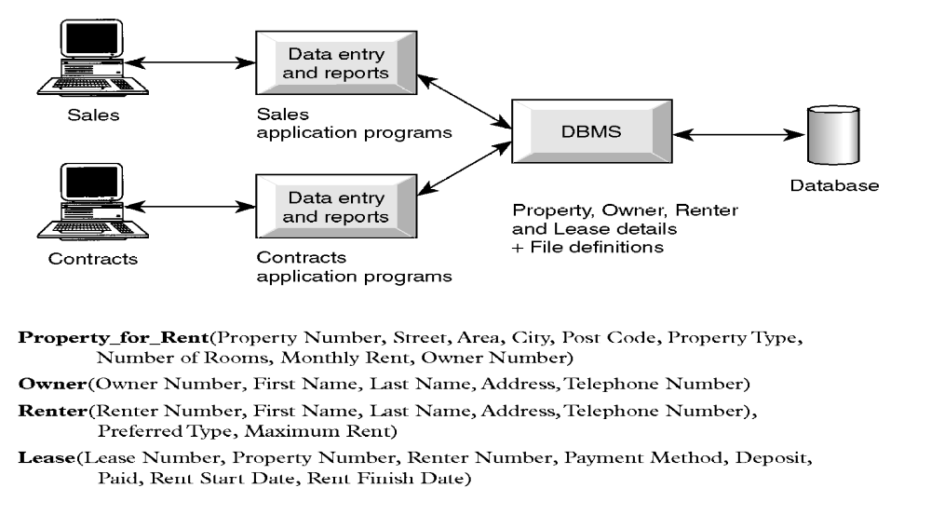
Centralized information control: since relevant data in the organization will be stored at one repository, it can be controlled and managed at the central level.
Limitations and risk of Database Approach
- Introduction of new professional and specialized personnel.
- Complexity in designing and managing data
- The cost and risk during conversion from the old to the new system
- High cost to be incurred to develop and maintain the system
- Complex backup and recovery services from the users perspective
- Reduced performance due to centralization and data independency
- High impact on the system when failure occurs to the central system.
Note: Database System (DBS) contains:
The Database + The DBMS + Application Programs (what users interact with)
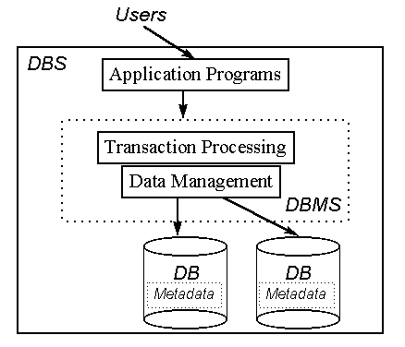

Components of a Database System
A database system involves four major components, namely, data, hardware, software and users and designers of database. A brief discussion will follow on each of these components.
Data: The actual data stored in the database system may be stored as a single database or distributed in many distinct files and treated as one. Is the system a single-user or multi-user one? How are we going to achieve the utmost possible performance concerning the data storage and maintenance? What other benefits or drawbacks do we expect as the result of placement or structure of the database?. These and similar issues might be concerned with the way the data stored in the system.
Hardware: This portion of the system consists of secondary storage media (disks, tapes and optical media) that are used to hold the stored data and associated device controllers (hard disk controller, etc.); and the processor(s) and associated main memory that are used to support the execution of the database system software.
Software: This is the software, Database Management System (DBMS) that is responsible for the overall management of communications between the user and the database. It is found between the data and the users, which, in other words, means the data is entirely covered or shielded by the DBMS software. The DBMS provides facilities for operating on the database. This is the most important software component in the overall system that allows the user to interact with the data.
Users and Designers of Database: As people are one of the components in DBS environment, there are group of roles played by different stakeholders of the designing and operation of a database system.

DataBase Administrator (DBA)

Responsible to oversee, control and manage the database resources (the database itself, the DBMS and other related software)

Authorizing access to the database

Coordinating and monitoring the use of the database

Responsible for determining and acquiring hardware and software resources

Accountable for problems like poor security, poor performance of the system

Involves in all steps of database development

We can have further classifications of this role in big organizations having huge amount of data and user requirement.

Data Administrator (DA): is responsible on management of data resources. Involves in database planning, development, maintenance of standards policies and procedures at the conceptual and logical design phases.

DataBase Administrator (DBA): is more technically oriented role. Responsible for the physical realization of the database. Involves in physical design, implementation, security and integrity control of the database.

Database Administrator a person that is responsible for all technical operations or details of the database system. The user that controls the enterprises data resource. The functions of the DBA include the following.
- Defining the conceptual schema: Will directly participate or help on the process of identifying the content of the database, i.e., what information is to be held in the database and create the corresponding conceptual schema using the conceptual DDL.
- Defining the internal schema: The DBA must also decide how the data is to be represented in the stored database and then create the corresponding storage structure definition (the internal schema) using the internal DDL (including associated mapping between the internal and conceptual schema).
- Liaising with users: By communicating with users the DBA will ensure that the data they require is available, and to write (or help users write) the necessary external schemas using the applicable external DDL. Other functions include consulting on application design, providing technical education, assisting with problem determination and resolution, and similar system related professional services.
- Defining security and integrity rules: Since security and integrity rules are part of the conceptual schema, the conceptual DDL should include facilities for specifying such rules.
- Defining backup and recovery procedures: In the event of damage to any portion of a database, caused by human error or failure in the hardware or operating system, it is essential to be able to repair the data concerned with the minimum of delay and with as little effect as possible on the rest of the system. The DBA should define and implement appropriate backup and recovery scheme.
- Monitoring performance and responding to changing requirements: Periodic performance analysis should be done by the DBA and based on the results obtained propose for improved systems and or do the modifications on the existing data definitions

Database Designer (DBD)

Identifies the data to be stored and choose the appropriate structures to represent and store the data.

Should understand the user requirement and should choose how the user views the database.

Involve on the design phase before the implementation of the database system.

We have two distinctions of database designers, one involving in the logical and conceptual design and another involving in physical design.

Logical and Conceptual DBD
    - Identifies data (entity, attributes and relationship) relevant to the organization
    - Identifies constraints on each data
    - Understand data and business rules in the organization
    - Sees the database independent of any data model at conceptual level and consider one specific data model at logical design phase.

Physical DBD
  - Take logical design specification as input and decide how it should be physically realized.
  - Map the logical data model on the specified DBMS with respect to tables and integrity constraints. (DBMS dependent designing)
  - Select specific storage structure and access path to the database
  - Design security measures required on the database

Application Programmer and Systems Analyst

System analyst determines the user requirement and how the user wants to view the database.

The application programmer implements these specifications as programs; code, test, debug, document and maintain the application program.

Determines the interface on how to retrieve, insert, update and delete data in the database.

The application could use any high level programming language according to the availability, the facility and the required service.
Application programmers who are responsible for writing application programs that use the database using some programming language such as COBOL, Pascal, or a programming language built-in to the DBMS.

End-users: These are those people who are engaged on processing different types of operations on the database system. Users are workers, whose job requires accessing the database frequently for various purpose. There are different group of users in this category.

Naïve Users:
    - Sizable proportion of users
    - Unaware of the DBMS
    - Only access the database based on their access level and demand
    - Use standard and pre-specified types of queries.

Sophisticated Users
    - Are users familiar with the structure of the Database and facilities of the DBMS.
    - Have complex requirements
    - Have higher level queries
    - Are most of the time engineers, scientists, business analysts, etc

Casual Users
    - Users who access the database occasionally.
    - Need different information from the database each time.
    - Use sophisticated database queries to satisfy their needs.
    - Are most of the time middle to high level managers.
Generally, End users are those that interact with the system from online workstations or terminals that use an application program developed by application programmers or those that query the system through an interface provided by the DBMS.

These users can be again classified as “Actors on the Scene” and “Workers Behind the Scene”.
Actors On the Scene:
- Data Administrator
- Database Administrator
- Database Designer
- End Users
Workers Behind the Scene
- DBMS designers and implementers: who design and implement different DBMS software.
- Tool Developers: experts who develop software packages that facilitates database system designing and use. Prototype, simulation, code generator developers could be an example. Independent software vendors could also be categorized in this group.
- Operators and Maintenance Personnel: system administrators who are responsible for actually running and maintaining the hardware and software of the database system and the information technology facilities.
Database Management System (DBMS)
Database Management System (DBMS) is the tool for creating and managing the large amounts of data efficiently and allowing it to persist for a long periods of time. Hence DBMS is a general-purpose software that facilities the processes of defining, constructing, manipulating, and sharing database.
- Defining: involves specifying data types, structure and constraints.
- Constructing: is the process of storing the data into a storage media.
- Manipulating: is retrieving and updating data from and into the storage.
- Sharing: allows multiple users to access data.
A DBMS is software that enables users to define, create, maintain and control access to the database. Example: Ms Access, FoxPro, SQL Server, MySQL, Oracle.

The phrase “Database System” is used to colloquially refer to database and database management system (DBMS).
- Database Management System (DBMS) is a Software package used for providing EFFICIENT, CONVENIENT and SAFE MULTI-USER (many people/programs accessing same database, or even same data, simultaneously) storage of and access to MASSIVE amounts of PERSISTENT (data outlives programs that operate on it) data.
- A DBMS also provides a systematic method for creating, updating, storing, retrieving data in a database.
- DBMS also provides the service of controlling data access, enforcing data integrity, managing concurrency control, and recovery. Having this in mind, a full scale DBMS should at least have the following services to provide to the user.

- Data storage, retrieval and update in the database
- A user accessible catalogue
- Transaction support service: ALL or NONE transaction, which minimize data inconsistency.
- Concurrency Control Services: access and update on the database by different users simultaneously should be implemented correctly.
- Recovery Services: a mechanism for recovering the database after a failure must be available.
- Authorization Services (Security): must support the implementation of access and authorization service to database administrator and users.
- Support for Data Communication: should provide the facility to integrate with data transfer software or data communication managers.
- Integrity Services: rules about data and the change that took place on the data, correctness and consistency of stored data, and quality of data based on business constraints.
- Services to promote data independency between the data and the application
Components of DBMS Environment
A DBMS is software package used to design, manage, and maintain databases. Each DBMS should have facilities to define the database, manipulate the content of the database and control the database. These facilities will help the designer, the user as well as the database administrator to discharge their responsibility in designing, using and managing the database. It provides the following facilities:
- Data Definition Language (DDL):
- Language used to define each data element required by the organization.
- Commands for setting up schema or the intension of database
- These commands are used to setup a database, create, delete and alter table with the facility of handling constraints
- Allows DBA or user to describe and name entitles, attributes and relationships required for the application.
- Specification notation for defining the database schema
- Data Manipulation Language (DML):
- Is a core command used by end-users and programmers to store, delete, and upate the data in the database e.g. SQL
- Provides basic data manipulation operations on data held in the database.
- Language for manipulating the data organized by the appropriate data model
- Data Query Language (DQL):
- Language for accessing or retrieving the data organized by the appropriate data model
- Since the required data or Query by the user will be extracted using this type of language, it is also called "Query Language"
  - Procedural DQL: user specifies what data is required and how to get the data.
  - Non-Procedural DQL: user specifies what data is required but not how it is to be retrieved
- Data Dictionary (DD):
- Due to the fact that a database is a self describing system, this tool, Data Dictionary, is used to store and organize information about the data stored in the database.
- Data Control Language (DCL):
- Database is a shared resource that demands control of data access and usage. The database administrator should have the facility to control the overall operation of the system.
- Data Control Languages are commands that will help the Database Administrator to control the database.
- The commands include grant or revoke privileges to access the database or particular object within the database and to store or remove database transactions

Database Development Life Cycle

As it is one component in most information system development tasks, there are several steps in developing a database system. Here more emphasis is given to the design phases of the database system development life cycle. The major steps in database system development are;
- Planning: that is identifying information gap in an organization and propose a database solution to solve the problem.
- Analysis: that concentrates more on fact finding about the problem or the opportunity. Feasibility analysis, requirement determination and structuring, and selection of best design method are also performed at this phase.
- Design: in database system development more emphasis is given to this phase. The phase is further divided into three sub-phases.
  - Conceptual Design: concise description of the data, data type, relationship between data and constraints on the data.
    - There is no implementation or physical detail consideration.
    - Used to elicit and structure all information requirements.
  - Logical Design: a higher level conceptual abstraction with selected specific database model to implement the data structure.
    - It is particular DBMS independent and with no other physical considerations.
  - Physical Design: physical implementation of the upper level design of the database with respect to internal storage and file structure of the database for the selected DBMS.
    - To develop all technology and organizational specification.
- Implementation: the testing and deployment of the designed database for use.
- Operation and Support: administering and maintaining the operation of the database system and providing support to users.

Basic Conceptes
- Database Design: The activity of specifying the schema of a database in a given data model
- Database Schema: The structure of a database that:
  - Captures data types, relationships and constraints in data
  - Is independent of any application program
  - Changes infrequently
- Data Model:
  - A set of primitives for defining the structure of a database.
  - A set of operations for specifying retrieval and updates on a database
  - Examples: Relational, Hierarchical, Networked, Object-Oriented
- Database Instance or State: The actual data contained in a database at a given time.
Database Systems Architecture
There may be several types of architectures of database systems. However, American National Standards Institute/ Standards Planning And R Commitee (ANSI/SPARC) architecture is applicable to most modern database systems. External level, Conceptual level and Internal level.
- All users should be able to access same data. This is important since the database is having a shared data feature where all the data is stored in one location and all users will have their own customized way of interacting with the data.
- A user's view is unaffected or immune to changes made in other views. Since the requirement of one user is independent of the other, a change made in one user’s view should not affect other users.
- Users should not need to know physical database storage details. As there are naïve users of the system, hardware level or physical details should be a black-box for such users.
- DBA should be able to change database storage structures without affecting the users' views. A change in file organization, access method should not affect the structure of the data which in turn will have no effect on the users.
- Internal structure of database should be unaffected by changes to physical aspects of storage.
- DBA should be able to change conceptual structure of database without affecting all users. In any database system, the DBA will have the privilege to change the structure of the database, like adding tables, adding and deleting an attribute, changing the specification of the objects in the database.

All the above and many other functionalities are possible due to the three level ANSI-SPARC Database System Architectures.
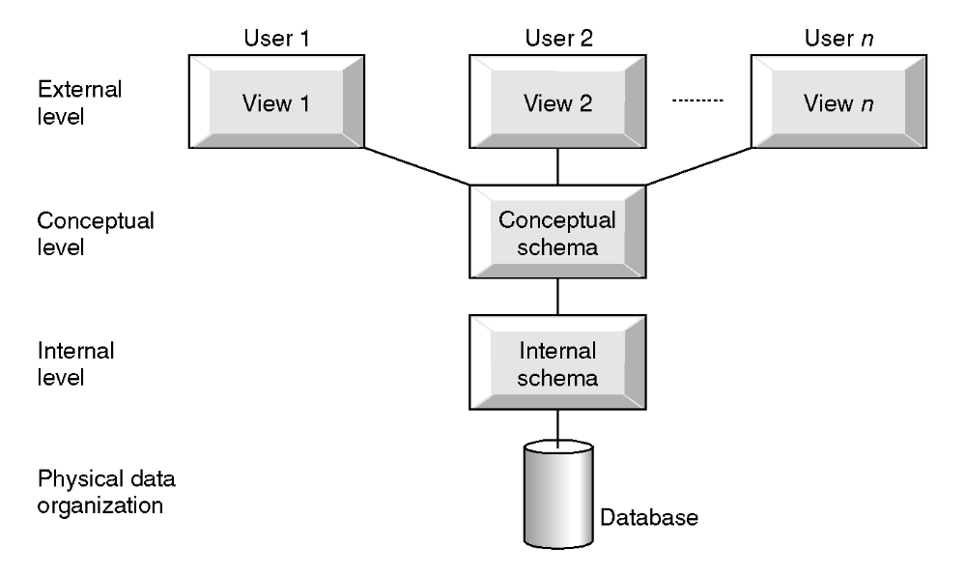

Three-level ANSI-SPARC Architecture of a Database System

ANSI-SPARC Architecture and Database Design Phases
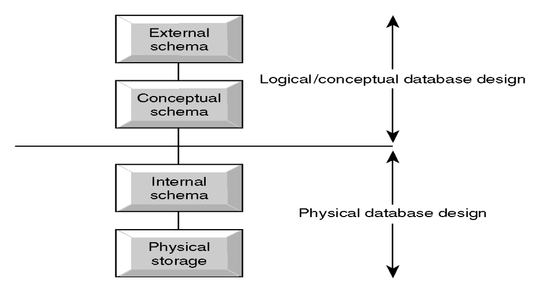
The Database System Architecture is consists of the three levels: External level, conceptual level, Internal level.
External Level:
The external level is the one closest to the users, i.e., it is the one concerned with the way the data is viewed by individual users. An external view is the content of the database as seen by some particular user (i.e., to that user the database is similar to the view he is working/accessing).
Each external view is defined by a means of an external schema, which consists basically of definitions of each of the various external record types in that external view. The external schema is written using the external DDL portion of the user’s data sub language.

External level is users' view of the database. Describes that part of database that is relevant to a particular user. Different users have their own customized view of the database independent of other users.

Conceptual Level:
- The conceptual level is found in between the other two. It is a representation of the entire information content of the database including the relations with one another and security and integrity rules, etc.
- It is the view of the data as it really is or by its entirety rather than as users are forced to see it by the constraints of (for example) the particular language or hardware they might be using.
- The conceptual view is defined by means of the conceptual schema, which is written using another DDL, the conceptual DDL of the data sublanguage in use. If data independence is to be achieved, then those conceptual DDL must not involve any considerations of storage structure or access technique. Thus there must be no reference in the conceptual schema to stored field representations, stored record sequence, indexing, hashing addressing, pointers or any other storage and access details.
- The conceptual schema includes a great many additional features, such as the security and integrity rules.

Conceptual level is community view of the database. Describes what data is
stored in database and relationships among the data.

Internal Level:
Is the one closest to the physical storage, i.e., it is concerned with the way the data is physically stored.
- Is a low-level representation of the entire database?
The internal view is described by means of the internal schema, which not only defines the various stored record types but also specifies what indexes exist, how stored fields are represented, what physical sequence the stored records are in, and so on. The internal schema is written using yet another DDL-the internal DDL.
There will be many distinct external views, each consisting of a more or less abstract representation of some portion of the total database, and there will be precisely one conceptual view, consisting of a similarly abstract representation of the database in its entirety. Note that most users will not be interested in the total database, but only in some restricted portion of it. Likewise, there will be precisely one internal view, representing the total database as physically stored. The following example will clarify the levels to some extent.
At the conceptual level, the database contains information concerning an entity type called employee. Each individual employee occurrence has an employee_number (six characters), a department_number (four characters), and a salary (five decimal digits).
At the internal level, employees are represented by a stored record type called stored_emp, twenty bytes long. Stored_emp contains four stored fields: a six byte prefix (presumably containing control information such as flags or pointers), and three data fields corresponding to the three properties of employees. In addition, stored_emp records are indexed on the empno field by an index called empx, whose definition is not shown.
The Pascal user has an external view of the database in which employee is represented by a Pascal record containing two fields (department numbers are of no interest to this user and therefore been omitted from the view). The record type is defined according to the syntax and declaration rules in Pascal.
Similarly, the COBOL user has an external view in which each employee is represented by a COBOL record containing two fields (this time salary is not needed by this user and omitted). The record type is defined according to COBOL rules.
Notice that: the corresponding objects can have different names at each level. The employee number is referred to as empno in the Pascal view, as emp# in the internal view and as employee_number in the conceptual view. In general, to define the correspondence between the conceptual view and the internal view; and the conceptual view and the external view we need an operation called mapping. The mappings are important, for example, fields can have different data types, field and record names can be changed, and several conceptual fields can be combined into a single external field, and so on.
Internal level is the physical representation of the database on the computer. Describes how the data is stored in the database.
The following example can be taken as an illustration for the difference
between the three levels in the ANSI-SPARC database system Architecture. Where:
- The first level is concerned about the group of users and their respective data requirement independent of the other.
- The second level is describing the whole content of the database where one piece of information will be represented once.
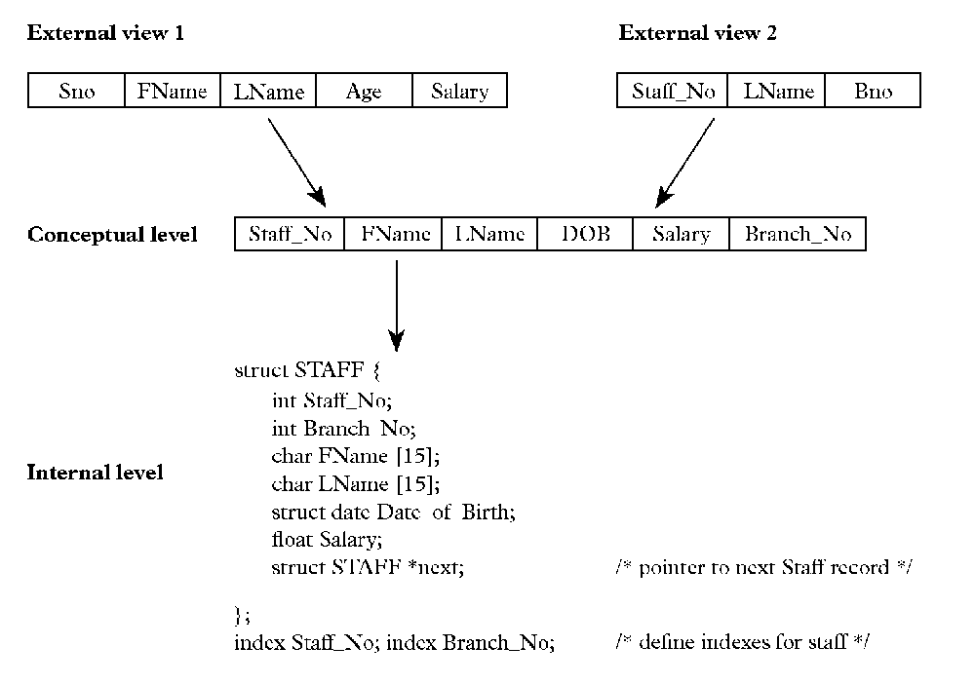
- The third level
Differences between Three Levels of ANSI-SPARC Architecture
Defines DBS schemas at three levels:
- Internal schema: at the internal level to describe physical storage structures and access paths. Typically uses a physical data model.
- Conceptual schema: at the conceptual level to describe the structure and constraints for the whole database for a community of users. Uses a conceptual or an implementation data model.
- External schema: at the external level to describe the various user views. Usually uses the same data model as the conceptual level.
Data Independence
Define as the ability (immunity) of applications to change storage structure and access technique without modifying the main application.

In older systems, the way in which the data is organized in secondary storage, and the technique for accessing it, are both dictated by the requirements of the application under consideration, and moreover that knowledge of that data organization and that access technique is built into the application logic and code. In such type of systems it is impossible to change the storage structures (how the data is physically stored) or access technique (how it is accessed) without affecting the application. The applications mentioned are simply programs that are designed to specific tasks where every knowledge of the data structure and the access mechanism is also defined within itself.

In database systems, it would be extremely undesirable to allow applications to be data dependent. Major reasons are:
Different applications will need different views of the same data. Suppose, we have an employee data stored with (employee_id, employee_name, employee_salary, and employee_address, etc. data items), one user may need only to use the employee_name and employee_salary data items whereas another user require only the employee_name and employee_address data items. For data dependent applications, such needs will entail the change of the main application with creation of two different copies of the same application, as it would be applied by both users.

The Database Administrator (DBA) must have the freedom to change the storage structure or access technique in response to changing requirements, without having to modify existing applications. For example, new kinds of data might be added to the database, new standards might be adopted; new types of storage devices might become available, and so on.

Logical Data Independence:
- Refers to immunity of external schemas to changes in conceptual schema.
- Conceptual schema changes e.g. addition or removal of entities should not require changes to external schema or rewrites of application programs.
- The capacity to change the conceptual schema without having to change the external schemas and their application programs.

Physical Data Independence
- The ability to modify the physical schema without changing the logical schema.
- Applications depend on the logical schema.
- In general, the interfaces between the various levels and components should be well defined so that changes in some parts do not seriously influence others.
- The capacity to change the internal schema without having to change the conceptual schema
- Refers to immunity of conceptual schema to changes in the internal schema
- Internal schema changes e.g. using different file organizations, storage structures/devices should not require change to conceptual or external schemas.

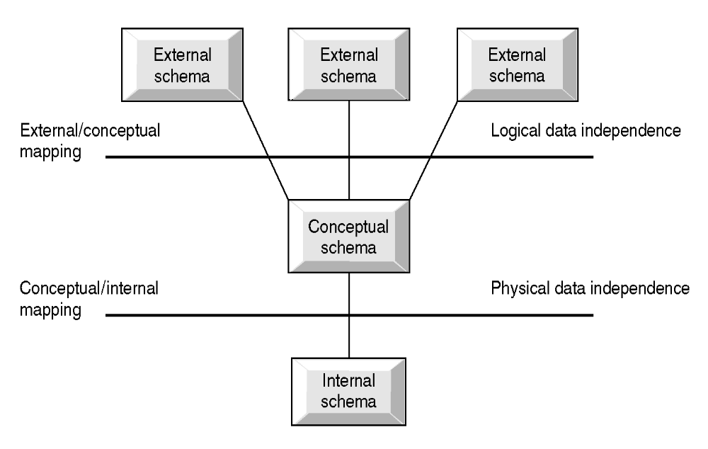
Data Independence and the ANSI-SPARC Three-level Architecture

UNIT TWO
Database Model
A database model is a conceptual description of how the database works. It describes how the data elements are stored in the database and how the data is presented to the user and programmer for access; and the relationship between different items in the database.

A specific DBS has its own specific Data Definition Language, but this type of language is too low level to describe the data requirements of an organization in a way that is readily understandable by a variety of users. We need a higher-level language. Such a higher-level is called database model.

Database Model: a set of concepts to describe the structure of a database, and certain constraints that the database should obey.

A database model is a description of the way that data is stored in a database. Database model helps to understand the relationship between entities and to create the most effective structure to hold data.

Database Model is a collection of tools or concepts for describing:
- Data
- Data relationships
- Data semantics
- Data constraints
The main purpose of database model is to represent the data in an understandable way.
Categories of database models include:
- Object-based
- Record-based
- Physical

Record-based Data Models
Consist of a number of fixed format records. Each record type defines a fixed number of fields, Each field is typically of a fixed length.The following are examples of this database model category.
- Hierarchical Database Model
- Network Database Model
- Relational Database Model
- Hierarchical Model
In this model, the data is organized in a tree structure that originates from a root, and each class of data resides at different levels along a particular branch of the root. The data structure at each class level is called a node. There is always a single root node which is usually owned by the system or DBMS. Each of the pointers in the root then will point to (child) nodes there by depicting a parent-child sort of relationship. Searches are done by traversing the tree up and down with known search algorithms and modules supplied by the DBMS or may, for special cases, be designed by the application programmer. The initial structure of the database must be defined by the application programmer when the database is created. From this point on, the parent-children structure can’t be changed without redesigning the whole structure.

Generally, Hierarchical database model is:
- The simplest database model
- Record type is referred to as node or segment
- The top node is the root node
- Nodes are arranged in a hierarchical structure as sort of upside-down tree
- A parent node can have more than one child node
- A child node can only have one parent node
- The relationship between parent and child is one-to-many and one-to-one
- Relation is established by creating physical link between stored records (each is stored with a predefined access path to other records)
- To add new record type or relationship, the database must be redefined and then stored in a new form.
Department
Job
Employee
Activity
Time Card

Advantages of Hierarchical Database Model:
- Hierarchical Model is simple to construct and operate on.
- Corresponds to a number of natural hierarchically organized domains-e.g., assemblies in manufacturing, personnel organization in companies.
- Language is simple; uses constructs like GET, GET UNIQUE, GET NEXT, GET NEXT WITHIN PARENT etc.
Disadvantages of Hierarchical Database Model:
- Navigational and procedural nature of processing.
- Database is visualized as a linear arrangement of records.
- Little scope for "query optimization".
- Network Model
The network is a conceptual description of databases where many-to-many (multiple parent-children) relationships exist. To make this model easier to understand, the relationships between the different data items are commonly referred to as sets to distinguish them from the strictly parent-child relationships defined by the HDBM.
The network model uses pointers to map the relationships between the different data items. The flexibility of the NDB model is in showing many-to-many relationships is its greatest strength, though the flexibility comes at a price (the interrelationships between the different data sets become extremely complex and difficult to map).

Like the HDBM, NDBMs can very quickly be searched, especially through the use of index pointers that lead directly to the first item in a set being searched. The NDBM suffers from the same structural problem as the HDBM; the initial design of the database is arbitrary, and once its setup, any changes to the different sets require the programmer to create an entirely new structure. The dual problems of duplicated data and inflexible structure led to the development of a database model that minimizes both problems by making relationships between the different data items the foundation for how the database is structure.

Generally, Network database model is
- Allows record types to have more that one parent unlike hierarchical
- A network database models sees records as set members
- Each set has an owner and one or more members
- Allows/supports many to many relationship between entities
- Like hierarchical model network model is a collection of physically linked records.
- Allow member records to have more than one owner
Department
Job
Employee
Activity
Time Card

Advantages of Network Data Model:
- Network Model is able to model complex relationships and represents semantics of add or delete on the relationships.
- Can handle most situations for modeling using record types and relationship types.
- Language is navigational; uses constructs like FIND, FIND member, FIND owner, FIND NEXT within set, GET etc. Programmers can do optimal navigation through the database.
Disadvantages of Network Data Model:
- Navigational and procedural nature of processing.
- Database contains a complex array of pointers that thread through a set of records.
- Little scope for automated "query optimization”.
- Relational Database Model
The relational database model is a way of looking at data- that is, it is a prescription for a way of representing data (namely, by means of tables), and a prescription for a way of manipulating such data (by means of operators). More precisely, the relational database model is concerned with three aspects of data: data structure (objects), data integrity, and data manipulation (operators).

The primary purpose behind the relational database model is the preservation of data integrity. To be considered truly relational, a DBMS must completely prevent access to the data by any means other than queries handled by the DBMS itself. While the relational model does not specify how the data is stored on the disk, the preservation of data integrity implies that the data must be stored in a format that prevents it from being accessed from outside the DBMS that created it.

The relational model also requires that the data be accessed through programs that don’t rely on the position of the data in the database. This is in direct contrast to the other database models, where the program has to follow a series of pointers to the data it wants. A program querying a relational database simply asks for the data it wants, and it is up to the DBMS to do the necessary searches and provide the answer. Searches can be speed up by creating an index on one or more columns in a table; however, the DBMS controls and uses the index. The user has only to ask the DBMS to create the index, and it will be maintained and used automatically from that point on.

The relational database model has a number of advantages over the other models. The most important is its complete flexibility in describing the relationships between the various data items. Once the tables are created and relationships defined then users can query the database on any of the individual columns in a table or on the relationships between the different tables.
Changing the structure of the database objects is as simple as adding or deleting columns in a table. Creating new tables, deleting old tables etc. are also very simple. The major tasks that the designers of a relational database has to make concerns the definitions of the tables and their relationships in the database.

Generally, Relational database model is
- Developed by Dr. Edgar Frank Codd in 1970 (famous paper, 'A Relational Model for Large Shared Data Banks').
- Terminologies originates from the branch of mathematics called set theory and relation.
- Can define more flexible and complex relationship.
- Viewed as a collection of tables called “Relations” equivalent to collection of record types.
- Relation: Two dimensional table.
- Stores information or data in the form of tables → rows and columns.
- A row of the table is called tuple→ equivalent to record.
- A column of a table is called attribute→ equivalent to fields.
- Data value is the value of the Attribute.
- Records are related by the data stored jointly in the fields of records in two tables or files. The related tables contain information that creates the relation.
- The tables seem to be independent but are related some how.
- No physical consideration of the storage is required by the user.
- Many tables are merged together to come up with a new virtual view of the relationship.
Alternative terminologies
Relation | Table | File
Tuple | Row | Record
Attribute | Column | Field
- The rows represent records (collections of information about separate items).
- The columns represent fields (particular attributes of a record).
- Conducts searches by using data in specified columns of one table to find additional data in another table.
- In conducting searches, a relational database model matches information from a field in one table with information in a corresponding field of another table to produce a third table that combines requested data from both tables.

UNIT THREE
Database Modeling Using the Entity-Relationship (ER) Database Model
Properties of Relational Databases - Basic Concepts in Relational Database
- Each row of a table is uniquely identified by a primary key (can be composed of one or more columns).
- Each tuple in a relation must be unique.
- Group of columns, that uniquely identifies a row in a table is called a candidate key.
- Entity integrity rule of the model states that no component of the primary key may contain a NULL value.
- A column or combination of columns that matches the primary key of another table is called a foreign key. This key is used to cross-reference tables.
- The referential integrity rule of the model states that, for every foreign key value in a table there must be a corresponding primary key value in another table in the database or it should be NULL.
- All tables are logical entities.
- A table is either a base tables (named relations) or views (Unnamed Relations).
- Only base tables are physically stores.
- Views are derived from base tables with SQL instructions like:
[select .. from .. where .. order by].
- Relatioal database is the collection of tables.
- Each entity in one table.
- Attributes are fields (columns) in table.
- Order of rows and columns is immaterial or irrelevant.
- Entries with repeating groups are said to be un-normalized.
- Entries are single-valued.
- Each column (field or attribute) has a distinct name.

All values in a column represent the same attribute and have the same data format.
Building Blocks of the Relational Database Model
The building blocks of the relational database model are:
- Entities: Real world physical or logical object.
- Attributes: Properties used to describe each Entity or real world object.
- Relationship: The association between the real world objects (i.e Entities.)
- Constraints: Rules that should be obeyed or followed while manipulating the data.
- ENTITIES: The entities (persons, places, things etc.) which the organization has to deal with. Relations can also describe relationships. The name given to an entity should always be a singular noun descriptive of each item to be stored in it. E.g.: student, NOT students. Every relation has a schema, which describes the columns, or fields, the relation itself corresponds to our familiar notion of a table: A relation is a collection of tuples, each of which contains values for a fixed number of attributes.
- Existence Dependency: The dependence of an entity on the existence of one or more entities.
- Weak entity : An entity that can not exist without the entity with which it has a relationship – it is indicated by a double rectangle.
- ATTRIBUTES - The items of information which characterize and describe these entities. Attributes are pieces of information about entities. The analysis must of course identify those which are actually relevant to the proposed application. Attributes will give rise to recorded items of data in the database. At this level we need to know such things as:
- Attribute name: Should be explanatory words or phrases.
- The domain: from which attribute values are taken (A domain is a set of values from which attribute values may be taken.) Each attribute has values taken from a domain. For example, the domain of Name is string and that for salary is real.
- Whether the attribute is part of the entity identifier (attributes which just describe an entity and those which help to identify it uniquely).
- Whether it is permanent or time-varying (which attributes may change their values over time).
- Whether it is required or optional for the entity (whose values will sometimes be unknown or irrelevant).
Types of Attributes
- Simple (atomic) Vs Composite attributes
- Simple : Contains a single value (not divided into sub parts)
E.g. Age, gender,etc.
- Composite: Divided into sub parts (composed of other attributes).
E.g. Name, address,etc.
- Single-valued Vs multi-valued attributes
- Single-valued : Have only single value (the value may change but has only one value at one time).
E.g. Name, Sex, Id. No. color_of_eyes, etc.
- Multi-Valued: Have more than one value.
E.g. Address, dependent-name, Person may have several college degrees, etc.
- Stored vs. Derived Attributes
- Stored : not possible to derive or compute.
E.g. Name, Address, etc.
- Derived: The value may be derived (computed) from the values of other attributes.
E.g. Age (current year – year of birth).
Length of employment (current date- start date).
Profit (earning-cost).
G.P.A (grade point/credit hours).

- Null Values
- NULL applies to attributes which are not applicable or which do not have values.
- You may enter the value NA (meaning not applicable).
- Value of a key attribute can not be null.
Default value - Assumed value if no explicit value.
Entity versus Attributes
When designing the conceptual specification of the database, one should pay attention to the distinction between an Entity and an Attribute.
- Consider designing a database of employees for an organization:
- Should address be an attribute of Employees or an entity (connected to Employees by a relationship)?
  - If we have several addresses per employee, address must be an entity (attributes cannot be set-valued/multi valued).
  - If the structure (city, Woreda, Kebele, etc) is important, e.g. want to retrieve employees in a given city, address must be modeled as an entity (attribute values are atomic).
- RELATIONSHIPS :The relationships between entities which exist and must be taken into account when processing information. In any business processing one object may be associated with another object due to some event. Such kind of association is what we call a relationship between entity objects.
- One external event or process may affect several related entities.
- Related entities require setting of links from one part of the database to another.
- A relationship should be named by a word or phrase which explains its function.
- Role names are different from the names of entities forming the relationship: one entity may take on many roles, the same role may be played by different entities.
- For each relationship, one can talk about the number of entities and the number of tuples participating in the association. These two concepts are called degree and cardinality of a relationship respectively.
Degree of a Relationship
Degree of relationship is an important point about a relationship which concerns how many entities are participate in it. The number of entities participating in a relationship is called the degree of the relationship. Among the Degrees of relationship, the following are the basic:
- Unary/recursive relationship: Tuples/records of a Single entity are related with each other.
- Binary relationships: Tuples/records of two entities are associated in a relationship.
- Ternary relationship: Tuples/records of three different entities are associated.
- And a generalized one:n-nary relationship: Tuples from arbitrary number of entity sets are participating in a relationship.
Cardinality of a Relationship
Another important concept about relationship is the number of instances/tuples that can be associated with a single instance from one entity in a single relationship. The number of instances participating or associated with a single instance from an entity in a relationship is called the cardinality of the relationship. The major cardinalities of a relationship are:
- One-to-one: one tuple is associated with only one other tuple.
  - E.g. Building -to- Location → as a single building will be located in a single location and as a single location will only accommodate a single Building.
- One-to-many: one tuple can be associated with many other tuples, but not the reverse.
  - E.g. Department-to-Student → as one department can have multiple students.
- Many-to-one: many tuples are associated with one tuple but not the reverse.
  - E.g. Employee–to-Department: as many employees belong to a single department.
- Many-to-many: one tuple is associated with many other tuples and from the other side, with a different role name one tuple will be associated with many tuples.
  - E.g. Student–to-Course→ as a student can take many courses and a single course can be attended by many students.

- Relational Constraints/Integrity Rules
Relational Integrity:
- Domain integrity: No value of the attribute should be beyond the allowable limits.
- Entity integrity: In a base relation, no attribute of a Primary Key can assume a value of NULL.
- Referential integrity: If a Foreign Key exists in a relation, either the Foreign Key value must match a Candidate Key value in its home relation or the Foreign Key value must be NULL.
- Enterprise integrity: Additional rules specified by the users or database administrators of a database are incorporated.
Keys and constraints
If tuples are need to be unique in the database, and then we need to make each tuple distinct. To do this we need to have relational keys that uniquely identify each relation.
A super key : A super key also know as super set is then a set of one or more attributes that in group (collectively) can identify an entity uniquely from the entity set.
Example: Consider the “EMPLOYEES” entity set, then
- “EmpId”, “EmpId, Name”, “NationalId”, “NationalId, BDate”, … are super keys
- “Name”, “BDate” are NOT super keys
Super Key: an attribute or set of attributes that uniquely identifies a tuple within a relation.
Note: If K is a super set (super key) then a set consisting of K is also a super set.
The more interesting super set is the minimal super set that is referred to as the candidate key.
The candidate key is the sufficient and the necessary set of attributes to distinguish an entity set.
Example: In the “EMPLOYEES” entity set
- “EmpId”, “NationalId”, “Name, BDate” (assuming that there is no coincidence that employees with the same name may born on the same day) … are candidate keys.
The designer of the database is the one that makes the choice of the candidate keys for implementation, but the choice has to be made carefully. Primary key is a term used to refer to the candidate key that is selected by the designer for implementation.
Candidate Key: an attribute or set of attributes that uniquely identifies individual occurrences of an entity type or tuple within a relation.
A candidate key has two properties:
- Uniqueness
- Irreducibility
Candidate Key: a super key such that no proper subset of that collection is a Super Key within the relation.

Composite key: A candidate key that consists of two or more attributes.
Primary key: the candidate key that is selected to identify tuples uniquely within the relation. The entire set of attributes in a relation can be considered as a primary case in a worst case.
In another way, an entity type may have one or more possible candidate keys, one of which is selected to be a primary key.
Foreign key: an attribute, or set of attributes, within one relation that matches the candidate key of some relation. A foreign key is a link between different relations to create the view or the unnamed relation.
Relational Views
Relations are perceived as a table from the users’ perspective. Actually, there are two kinds of relation in relational database. The two categories or types of relations are Base (Named) and View (Unnamed) Relations. The basic difference is on how the relation is created, used and updated:
- Base Relation: A named relation corresponding to an entity in the conceptual schema, whose tuples are physically stored in the database.
- View (Unnamed Relation): A View is the dynamic result of one or more relational operations operating on the base relations to produce another virtual relation that does not actually exist as presented. So a view is virtually derived relation that does not necessarily exist in the database but can be produced upon request by a particular user at the time of request. The virtual table or relation can be created from single or different relations by extracting some attributes and records with or without conditions.
Purpose of a view
- Hides unnecessary information from users: since only part of the base relation (Some collection of attributes, not necessarily all) are to be included in the virtual table.
- Provide powerful flexibility and security: since unnecessary information will be hidden from the user there will be some sort of data security.
- Provide customized view of the database for users: each users are going to be interfaced with their own preferred data set and format by making use of the Views.
- A view of one base relation can be updated.
- Update on views derived from various relations is not allowed since it may violate the integrity of the database.
- Update on view with aggregation and summary is not allowed. Since aggregation and summary results are computed from a base relation and does not exist actually.
Schemas and Instances
When a database is designed using a relational data model, all the data is represented in a form of a table. In such definitions and representation, there are two basic components of the database. The two components are the definition of the relation or the table and the actual data stored in each table. The data definition is what we call the Schema or the skeleton of the database and the relations with some information at some point in time is the Instance or the flesh of the database.
Schemas
Schema describes how data is to be structured, defined at setup/design time (also called "metadata"). Since it is used during the database development phase, there is rare tendency of changing the schema unless there is a need for system maintenance which demands change to the definition of a relation.
- Database Schema (Intension): specifies name of relation and the collection of the attributes (specifically the Name of attributes).
- refer to a description of database (or intention)
- specified during database design
- should not be changed unless during maintenance
- Schema Diagrams: convention to display some aspect of a schema visually.
- Schema Construct: refers to each object in the schema (e.g. STUDENT)
E.g.: STUNEDT (FName,LName,Id,Year,Dept,Sex)
Instances
Instance: is the collection of data in the database at a particular point of time (snap-shot).
- Also called State or Snap Shot or Extension of the database.
- Refers to the actual data in the database at a specific point in time.
- State of database is changed any time we add, delete or update an item.
- Valid state: the state that satisfies the structure and constraints specified in the schema and is enforced by DBMS.
Since instance is actual data of database at some point in time, changes rapidly. To define a new database, we specify its database schema to the DBMS (database is empty). Database is initialized when we first load it with data.
ENTITY - RELATIONSHIP DIAGRAMS
As one important aspect of E-R modeling, database designers represent their data model by E-R diagrams. These diagrams enable designers and users to express their understanding of what the planned database is intended to do and how it might work, and to communicate about the database through a common language. Each organization that uses E-R diagrams must adopt a specific style for representing the various components.

Graphical Representations in ER Diagramming
- Entity is represented by a rectangle containing the name of the entity.

Strong Entity

Weak Entity

- Connected entities are called relationship participants
- Attributes are represented by ovals and are connected to the entity by a line.
Ovals
Composite
Attribute
Multi-valued
Attribute
Ovals
Ovals
Ovals
Ovals
Ovals
Attribute

- A derived attribute is indicated by a dotted line. (……..)
Key
Ovals
- Primary Keys are underlined.
- Relationships are represented by Diamond shaped symbols
  - Weak Relationship is a relationship between Weak and Strong Entities.
  - Strong Relationship is a relationship between two strong Entities.

Weak Relationship
Strong Relationship

An entity-relationship model (ERM) is a model that provides a high-level description of a conceptual data model. Data modeling that provides a graphical notation for representing such data models in the form of entity-relationship diagrams (ERD).

The whole purpose of ER modeling is to create an accurate reflection of the real world in a database. The ER model doesn’t actually give us a database description. It gives us an intermediate step from which it is easy to define a database.

The E-R data model is based on a perception of a real world that consists of a set of basic objects called entities, and of relationships among these objects. It was developed to facilitate database design by allowing the specification of an enterprise schema, which represents the overall logical structure of a database.

The E-R data model is one of several semantic data models; the semantic aspect of the model lies in the attempt to represent the meaning of the data. The E-R model is extremely useful in mapping the meanings and interactions of real-world enterprises onto a conceptual scheme. Because of this utility, many database design tools draw on concepts from the E-R model.

A data model in which information stored in the database is viewed as sets of entities and sets of relationships among entities. There are three basic notions that the ER Model employs: entity sets, relationships, and attributes.
UNIT FOUR
Database Design
Database design is the process of coming up with different kinds of specification for the data to be stored in the database. The database design part is one of the middle phases we have in information systems development (DBS) where the system uses a database approach. Design is the part on which we would be engaged to describe how the data should be perceived at different levels and finally how it is going to be stored in a computer system.

Information System with Database application (DBS development life cycles)consists of several tasks which include:
- Planning of Information systems Design
- Requirements Analysis
- Design (Conceptual, Logical and Physical Design)
- Tuning
- Implementation
- Operation and Support

From these different phases, the prime interest of a database system development will be the design part which is again sub divided into other three sub-phases. These sub-phases are:
- Conceptual Database Design
- Logical Design Database, and
- Physical Database Design
In general, one has to go back and forth between these tasks to refine a database design, and decisions in one task can influence the choices in another task. In developing a good design, one should answer such questions as:
- What are the relevant Entities for the Organization
- What are the important features of each Entity
- What are the important Relationships
- What are the important queries from the user
- What are the other requirements of the Organization and the Users

The Three levels of Database Design
Conceptual Design
Logical Design
Physical Design

Conceptual Database Design
Conceptual design is the process of constructing a model of the information used in an enterprise, independent of any physical considerations.
- It is the source of information for the logical design phase.
- Mostly uses an Entity Relationship Model to describe the data at this level.
- After the completion of Conceptual Design one has to go for refinement of the schema, which is verification of Entities, Attributes, and Relationships.
Logical Database Design
Logical design is the process of constructing a model of the information used in an enterprise based on a specific database model (e.g. Relational, Hierarchical or Network or Object), but independent of a particular DBMS and other physical considerations.

Normalization process
- Collection of Rules to be maintained.
- Discover new entities in the process.
- Revise attributes based on the rules and the discovered Entities.

Physical Database Design
Physical design is the process of producing a description of the implementation of the database on secondary storage. -- defines specific storage or access methods used by database.
- Describes the storage structures and access methods used to achieve efficient access to the data.
- Tailored to a specific DBMS system -- Characteristics are function of DBMS and operating systems.
- Includes estimate of storage space.
NOTE:
In conceptual data model/Design
- Identify what are the entities/entity types
- Identify what are the attributes: - the information about entities and relationship should we store in the database.
- Identify relationship types
- Identify what are the constraints/business rules that hold?
- Draw entity-relationship diagram:- representing the database in the ER model using pictorial representation called ER diagram
- Review the conceptual data model with user
In logical data model/Design
- Map the conceptual model to a logical model
- Mapping entities and relationships in ER-Diagram into tables
-Translate ER-diagram with constraints
- Derive relations from the logical data model
- Validate model using normalization
- Validate model against user transactions
- Draw entity-relationship diagram
- Define integrity constraints
- Check for future growth

NB: Startng from this we are going to design database using the relational database model.
Conceptual Database Design
Conceptual design revolves around discovering and analyzing organizational and user data requirements. The important activities are to identify
- Entities
- Attributes
- Relationships
- Constraints
And based on these components develop the ER model using
- ER diagrams
The Entity Relationship (E-R) Model
An entity-relationship (E-R) data model is a high-level conceptual model that describes data as entities, attributes, and relationships. The E-R model is represented by E-R diagrams that show how data will be represented and organized in the various components of the final database. However, the model diagrams do not specify the actual data, or even exactly how it is stored. The users and applications will create the data content and the database management system will create the database to store the content.

Entity-Relationship modeling is used to represent conceptual view of the database. The main components of ER Modeling are:
- Entities
  - Corresponds to entire table, not row
  - Represented by Rectangle
- Attributes
  - Represents the property used to describe an entity or a relationship
  - Represented by Oval
- Relationships
  - Represents the association that exist between entities
  - Represented by Diamond
- Constraints
  - Represent the constraint in the data
Before working on the conceptual design of the database, one has to know and answer the following basic questions.
- What are the entities and relationships in the enterprise?
- What information about these entities and relationships should we store in the database?
- What are the integrity constraints that hold? Constraints on each data with respect to update, retrieval and store.
- Represent this information pictorially in ER diagrams, then map ER diagram into a relational schema.
Developing an E-R Diagram
Designing conceptual model for the database is not a one linear process but an iterative activity where the design is refined again and again. To identify the entities, attributes, relationships, and constraints on the data, there are different set of methods used during the analysis phase. These include information gathered by.
- Interviewing end users individually and in a group
- Questionnaire survey
- Direct observation
- Examining different documents

The basic E-R model is graphically depicted and presented for review. The process is repeated until the end users and designers agree that the E-R diagram is a fair representation of the organization’s activities and functions. Checking for Redundant Relationships in the ER Diagram. Relationships between entities indicate access from one entity to another - it is therefore possible to access one entity occurrence from another entity occurrence even if there are other entities and relationships that separate them - this is often referred to as Navigation' of the ER diagram. The last phase in ER modeling is validating an ER Model against requirement of the user.

Example 1: Build an E-R Diagram for the following information:
A student record management system will have the following two basic data object categories with their own features or properties: Students will have an Id, Name, Dept, Age, GPA and Course will have an Id, Name, Credit Hours. Whenever a student enroll in a course in a specific Academic Year and Semester, the Student will have a grade for the course.
Name
Students
Name
Dept
Id
DoB
Gpa
Courses
Id
Credit
Enrolled_In
Grade
Semester
Academic Year
Age
Example 2: Build an ER Diagram for the following information:
A Personnel record management system will have the following two basic data object categories with their own features or properties: Employee will have an Id, Name, DoB, Age, Tel and Department will have an Id, Name, Location. Whenever an Employee is assigned in one Department, the duration of his stay in the respective department should be registered.
Structural Constraints on Relationship
- Constraints on Relationship/Multiplicity/ Cardinality Constraints: Multiplicity constraint is the number or range of possible occurrence of an entity type/relation that may relate to a single occurrence/tuple of an entity type/relation through a particular relationship. Mostly used to insure appropriate enterprise constraints.

One-to-one relationship:
  - A customer is associated with at most one loan via the relationship borrower.A loan is associated with at most one customer via borrower.
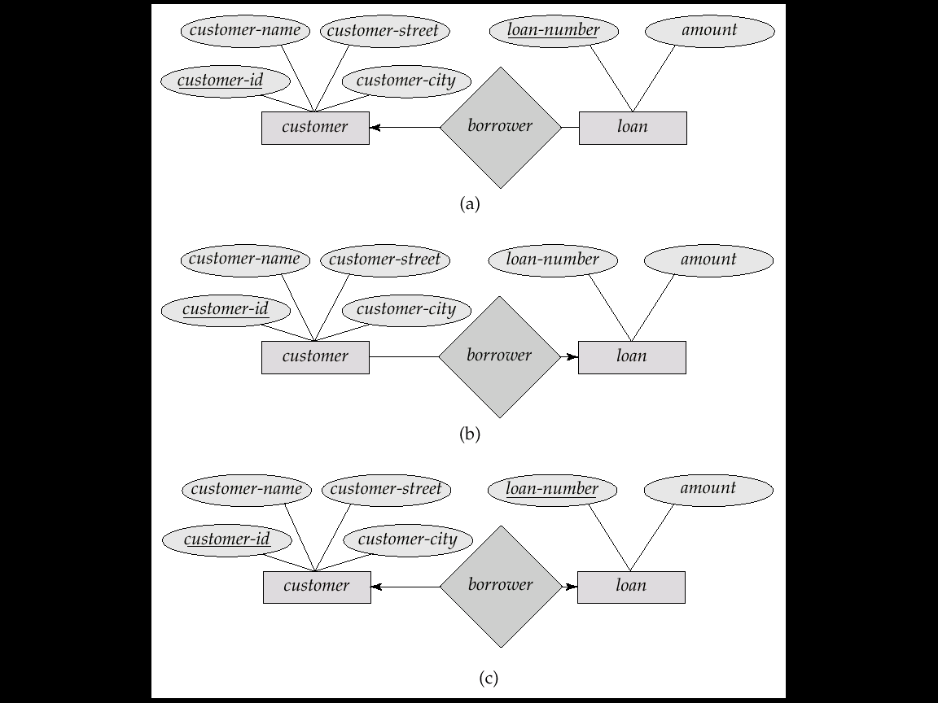
E.g.: Relationship Manages between Staff and Branch.
The multiplicity of the relationship is:
- One branch can only have one manager.
- One employee could manage either one or no branches.
1..1
0..1
Employee
Branch
Manages
One-To-Many Relationships
  - In the one-to-many relationship a loan is associated with at most one customer via borrower, a customer is associated with several (including 0) loans via borrower.

E.g.: Relationship Leads between Staff and Project
The multiplicity of the relationship is:
- One staff may Lead one or more project(s)
- One project is Lead by one staff
1..1
0..*
Employee
Project
Leads
Many-To-Many Relationship
  - A customer is associated with several (possibly 0) loans via borrower. A loan is associated with several (possibly 0) customers via borrower.
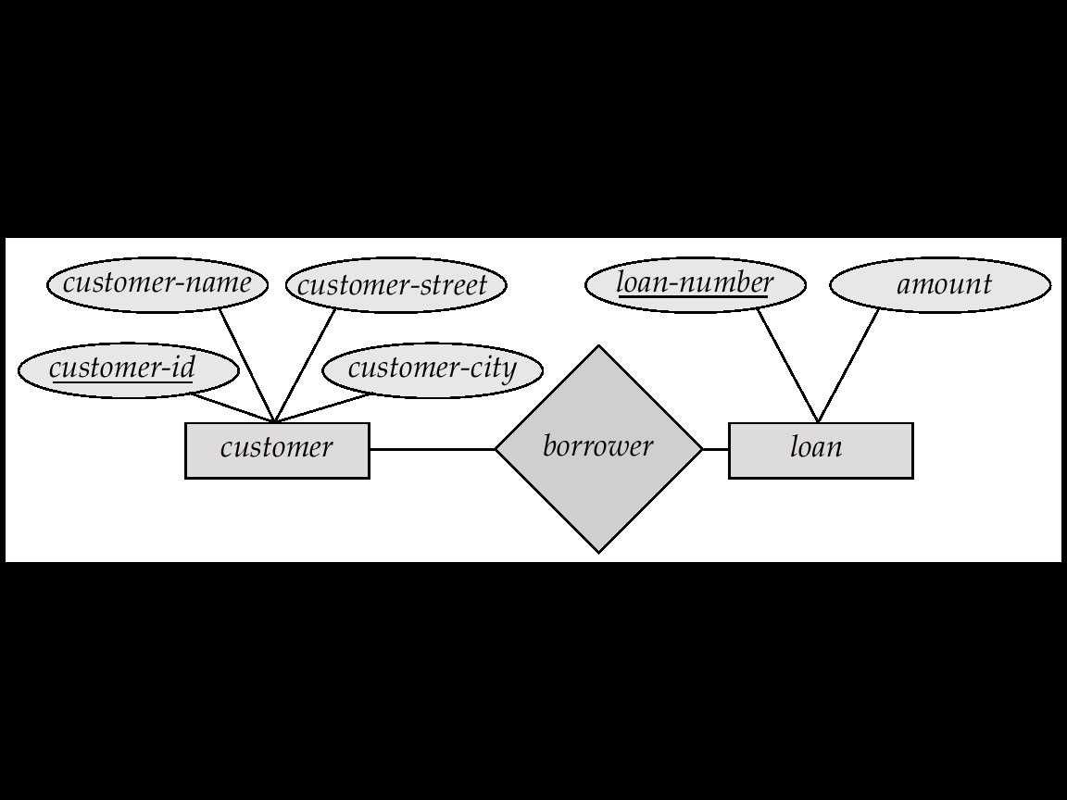
E.g.: Relationship Teaches between instructor and course
The multiplicity of the relationship
- One Instructor Teaches one or more Course(s)
- One Course Thought by Zero or more Instructor(s)
0..*
1..*
Instructor
Course
Teaches
- Participation of an Entity Set in a Relationship Set=Particpation constraints
Participation constraint of a relationship is involved in identifying and setting the mandatory or optional feature of an entity occurrence to take a role in a relationship. There are two distinct participation constraints with this respect, namely: Total Participation and Partial Participation.
- Total participation: every tuple in the entity or relation participates in at least one relationship by taking a role. This means, every tuple in a relation will be attached with at least one other tuple. The entity with total participation in a relationship will be connected to the relationship using a double line.
- Partial participation: some tuple in the entity or relation may not participate in the relationship. This means, there is at least one tuple from that Relation not taking any role in that specific relationship. The entity with partial participation in a relationship will be connected to the relationship using a single line.
- E.g. 1: Participation of employee in “belongs to” relationship with Department is total since every employee should belong to a department. Participation of department in “belongs to” relationship with employee is total since every department should have more than one employee.
Employee
Department
Belongs To

- E.g. 2: Participation of employee in “manages” relationship with Department, is partial participation since not all employees are managers. Participation of department in “Manages” relationship with employee is total since every department should have a manager.
Employee
Department
Manages

Problem in ER Modeling
The Entity-Relationship Model is a conceptual data model that views the real world as consisting of entities and relationships. The model visually represents these concepts by the Entity-Relationship diagram. The basic constructs of the ER model are entities, relationships, and attributes. Entities are concepts, real or abstract, about which information is collected. Relationships are associations between the entities. Attributes are properties which describe the entities.

While designing the ER model one could face a problem on the design which is called a connection traps. Connection traps are problems arising from misinterpreting certain relationships.
There are two types of connection traps;
- Fan trap:
Occurs where a model represents a relationship between entity types, but the pathway between certain entity occurrences is ambiguous.
May exist where two or more one-to-many (1:M) relationships fan out from an entity. The problem could be avoided by restructuring the model so that there would be no 1:M relationships fanning out from a singe entity and all the semantics of the relationship is preserved.
Example:

Employee

Branch

Car
1..* Works 1..1
For

1..1 IsAssigned 1..*

Semantics description of the problem;
Emp1
Emp2
Emp3
Emp4
Emp5
Emp6
Emp7

Bra1
Bra2
Bra3
Bra4

Car1
Car2
Car3
Car4
Car5
Car6
Car7

Problem: Which car (Car1 or Car3 or Car5) is used by Employee 6. Emp6 working in Branch 1 (Bra1). Thus from this ER Model one can not tell which car is used by which staff since a branch can have more than one car and also a branch is populated by more than one employee. Thus we need to restructure the model to avoid the connection trap.

To avoid the Fan Trap problem we can go for restructuring of the E-R Model. This will result in the following E-R Model.

Branch

Car

1..* Used By 1..*

1..1 Has 1..*

Employee

Semantics description of the problem;
Car1
Car2
Car3
Car4
Car5
Car6
Car7

Bra1
Bra2
Bra3
Bra4

Emp1
Emp2
Emp3
Emp4
Emp5
Emp6
Emp7

- Chasm Trap:
Occurs where a model suggests the existence of a relationship between entity types, but the path way does not exist between certain entity occurrences.
May exist when there are one or more relationships with a minimum multiplicity on cardinality of zero forming part of the pathway between related entities.
Example:

Branch

Employee

project
0..1 Manages 0..*

1..1 Has 1..*

If we have a set of projects that are not active currently then we can not assign a project manager for these projects. So there are project with no project manager making the participation to have a minimum value of zero.
Problem:
How can we identify which Branch is responsible for which Project? We know that whether the project is active or not there is a responsible Branch. But which branch is a question to be answered, and since we have a minimum participation of zero between employee and project we can’t identify the branch responsible for each project.

The solution for this Chasm Trap problem is to add another relationship between the extreme entities (Branch and Project).

0..1 Manages 0..*

1..1 Has 1..*

1..1 Responsible for 1..*

Branch

Employee

project

Enhanced E-R (E-ER) Model
Object-oriented extensions to E-R model. EER is important when we have a relationship between two entities and the participation is partial between entity occurrences. In such cases EER is used to reduce the complexity in participation and relationship complexity. ER diagrams consider entity types to be primitive objects. EER diagrams allow refinements within the structures of entity types.
EER Concepts: In this part we will discuss the following basic EER concepts.
- Generalization
- Specialization
- Sub classes
- Super classes
- Attribute Inheritance
- Constraints on specialization and generalization
Generalization
Generalization occurs when two or more entities represent categories of the same real-world object. Generalization is the process of defining a more general entity type from a set of more specialized entity types. A generalization hierarchy is a form of abstraction that specifies that two or more entities that share common attributes can be generalized into a higher level entity type. Generalization is considered as bottom-up definition of entities. Generalization hierarchy depicts relationship between higher level superclass and lower level subclass.

Generalization hierarchies can be nested. That is, a subtype of one hierarchy can be a supertype of another. The level of nesting is limited only by the constraint of simplicity.
Example: Account is a generalized form for Saving and Current Accounts.
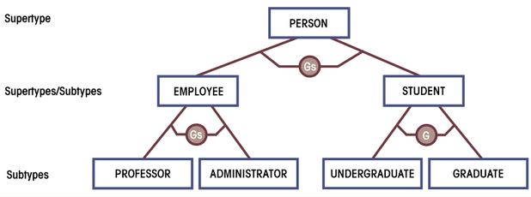
Specialization
Specialization is the result of subset of a higher level entity set to form a lower level entity set. The specialized entities will have additional set of attributes (distinguishing characteristics) that distinguish them from the generalized entity. Is considered as Top-Down definition of entities. Specialization process is the inverse of the Generalization process. Identify the distinguishing features of some entity occurrences, and specialize them into different subclasses.
Reasons for Specialization are:
- Attributes only partially applying to superclasses.
- Relationship types only partially applicable to the superclass.
In many cases, an entity type has numerous sub-groupings of its entities that are meaningful and need to be represented explicitly. This need requires the representation of each subgroup in the ER model. The generalized entity is a superclass and the set of specialized entities will be subclasses for that specific Superclass.
Example: Saving Accounts and Current Accounts are Specialized entities for the generalized entity Accounts. Manager, Sales, Secretary: are specialized employees.

Subclass/Subtype
An entity type whose tuples have attributes that distinguish its members from tuples of the generalized or Superclass entities. When one generalized Superclass has various subgroups with distinguishing features and these subgroups are represented by specialized form, the groups are called subclasses. Subclasses can be either mutually exclusive (disjoint) or overlapping (inclusive). A single subclass may inherit attributes from two distinct superclasses. A mutually exclusive category/subclass is when an entity instance can be in only one of the subclasses. E.g.: An employee can either be Salaried or Part-Timer but not both.

An overlapping category/subclass is when an entity instance may be in two or more subclasses. E.g.: A person who works for a university can be both employee and a student at the same time.
Superclass /Supertype
An entity type whose tuples share common attributes. Attributes that are shared by all entity occurrences (including the identifier) are associated with the supertype. Superclass /Supertype Is the generalized entity.
Relationship Between Superclass and Subclass
The relationship between a superclass and any of its subclasses is called a superclass/subclass or class/subclass relationship. An instance can not only be a member of a subclass. i.e. Every instance of a subclass is also an instance in the Superclass. A member of a subclass is represented as a distinct database object, a distinct record that is related via the key attribute to its super-class entity. An entity cannot exist in the database merely by being a member of a subclass; it must also be a member of the super-class. An entity occurrence of a sub class not necessarily should belong to any of the subclasses unless there is full participation in the specialization. A member of a subclass is represented as a distinct database object, a distinct record that is related via the key attribute to its super-class entity. The relationship between a subclass and a Superclass is an “IS A” or “IS PART OF” type.
    - Subclass IS PART OF Superclass
    - Manager IS AN Employee
All subclasses or specialized entity sets should be connected with the superclass using a line to a circle where there is a subset symbol indicating the direction of subclass/superclass relationship.
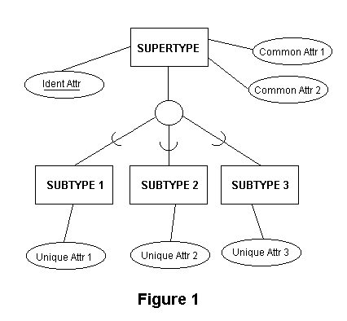

We can also have subclasses of a subclass forming a hierarchy of specialization. Superclass attributes are shared by all subclasses f that superclass. Subclass attributes are unique for the subclass.
Attribute Inheritance
An entity that is a member of a subclass inherits all the attributes of the entity as a member of the superclass. The entity also inherits all the relationships in which the superclass participates. An entity may have more than one subclass categories. All entities/subclasses of a generalized entity or superclass share a common unique identifier attribute (primary key). i.e. The primary key of the superclass and subclasses are always identical.
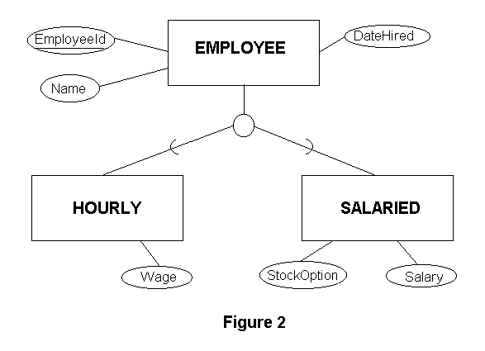
Consider the EMPLOYEE supertype entity shown above. This entity can have several different subtype entities (for example: HOURLY and SALARIED), each with distinct properties not shared by other subtypes. But whether the employee is Hourly or Salaried, same attributes (EmployeeId, Name, and DateHired) are shared. The Supertype EMPLOYEE stores all properties that subclasses have in common. And HOURLY employees have the unique attribute Wage (hourly wage rate), while SALARIED employees have two unique attributes, StockOption and Salary.
Constraints on specialization and generalization
Completeness Constraint.
The Completeness Constraint addresses the issue of whether or not an occurrence of a Superclass must also have a corresponding Subclass occurrence. The completeness constraint requires that all instances of the subtype be represented in the supertype. The Total Specialization Rule specifies that an entity occurrence should at least be a member of one of the subclasses. Total Participation of superclass instances on subclasses is diagrammed with a double line from the Supertype to the circle as shown below. E.g.: If we have Extention and regular as subclasses of a superclass student, then it is mandatory that each student to be either Extention or regular student. Thus the participation of instances of student in Extention and regular subclasses will be total.
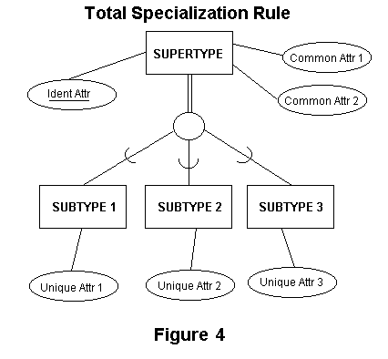

The Partial Specialization Rule specifies that it is not necessary for all entity occurrences in the superclass to be a member of one of the subclasses. Here we have an optional participation on the specialization. Partial Participation of superclass instances on subclasses is diagrammed with a single line from the Supertype to the circle. E.g.: If we have Manager and Secretary as subclasses of a superclass Employee, then it is not the case that all employees are either manager or secretary. Thus the participation of instances of employee in manager and secretary subclasses will be partial.
Disjointness Constraints
Specifies the rule whether one entity occurrence can be a member of more than one subclasses. i.e. it is a type of business rule that deals with the situation where an entity occurrence of a Superclass may also have more than one Subclass occurrence. The Disjoint Rule restricts one entity occurrence of a superclass to be a member of only one of the subclasses. Example: a Employee can either be salaried or part-timer, but not the both at the same time. The Overlap Rule allows one entity occurrence to be a member f more than one subclass. Example: Employee working at the university can be both a Student and an employee at the same time. This is diagrammed by placing either the letter "d" for disjoint or "o" for overlapping inside the circle on the Generalization Hierarchy portion of the E-R diagram.
The two types of constraints on generalization and specialization (Disjointness and Completeness constraints) are not dependent on one another. That is, being disjoint will not favour whether the tuples in the superclass should have Total or Partial participation for that specific specialization.
From the two types of constraints we can have four possible constraints
- Disjoint AND Total
- Disjoint AND Partial
- Overlapping AND Total
- Overlapping AND Partial

